Rohan Raj

Raza Hashim

T5

Task 1a:

add x10, x1, x2 # b = 0 + 0;

add x3, x10, x4 # a = b + 3 2;

add x5, x10, x3 # c = a + b ;

sub x7, x5, x6 # d = c − 5;

add x8, x5, x7 # x = c + d

add x9, x5, x8 # e = x + c since a + b = c, we c is used instead

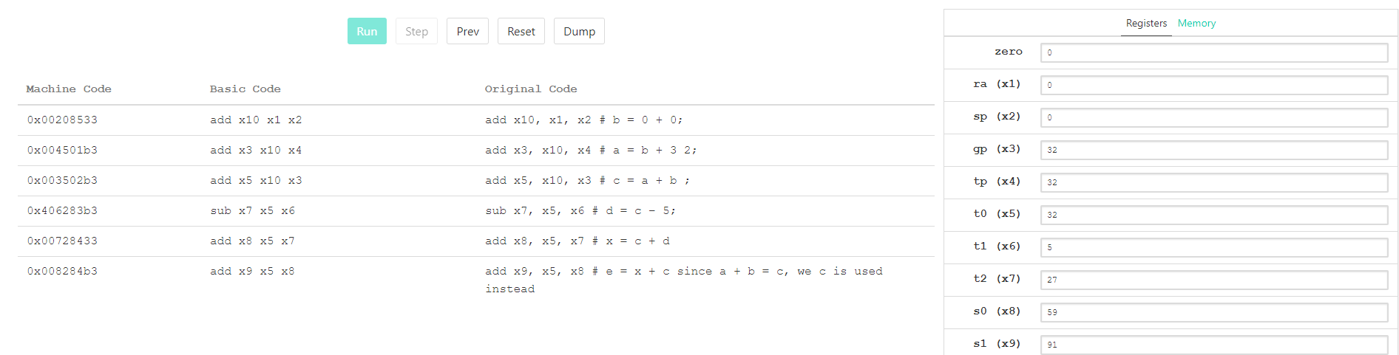

Explanation:

We are adding the values in each of these registers and storing it to a new register

Using addi:

add x10, x1, x2 # b = 0 + 0;

addi x3, x10, 32 # a = b + 3 2;

add x5, x10, x3 # c = a + b ;

addi x7, x5, -5 # d = c − 5;

add x8, x5, x7 # x = c + d

add x9, x5, x8 # e = x + c since a + b = c, we c is used instead

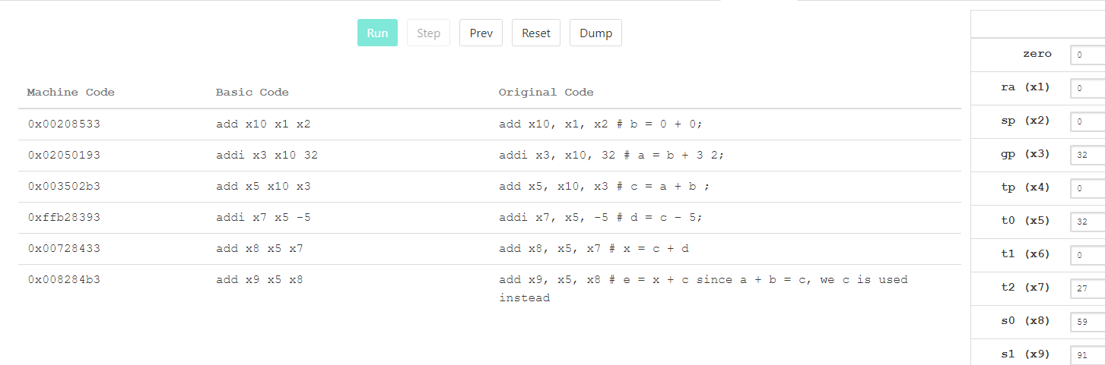

Task 1b:

sub x1, x2, x3 # a−d

sub x4, x5, x2 # (b−a )

add x6, x1, x4 # ( a−d )+(b−a )

add x7, x6, x3 # ( ( a−d )+(b−a ) )+d

addi x8, x7, -55 # ( ( ( a−d )+(b−a ) )+d )−c

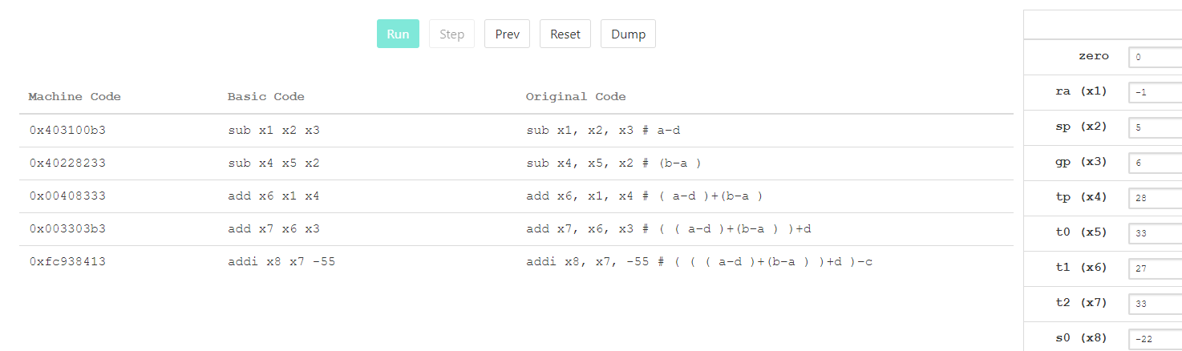

Explanation:

We are adding and subtracting the values in each of these registers and storing it to a new register

Task 2a:

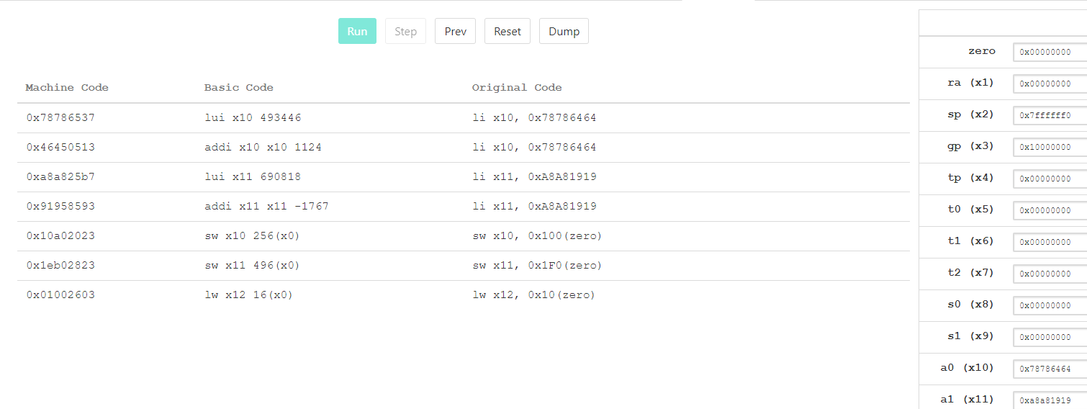

1)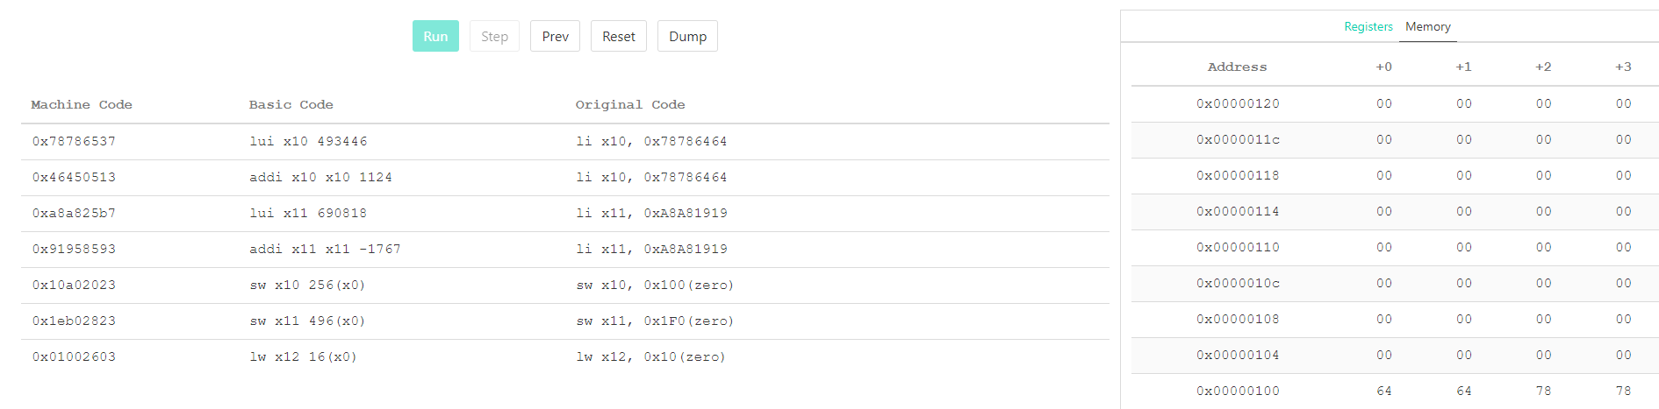

2)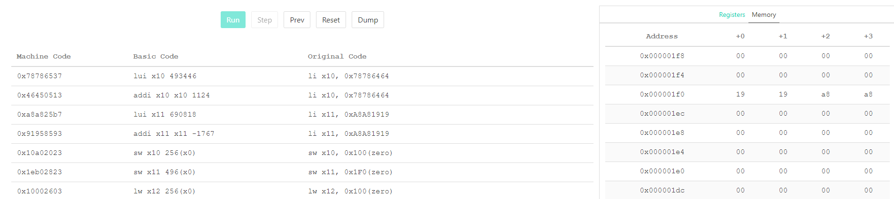

3) 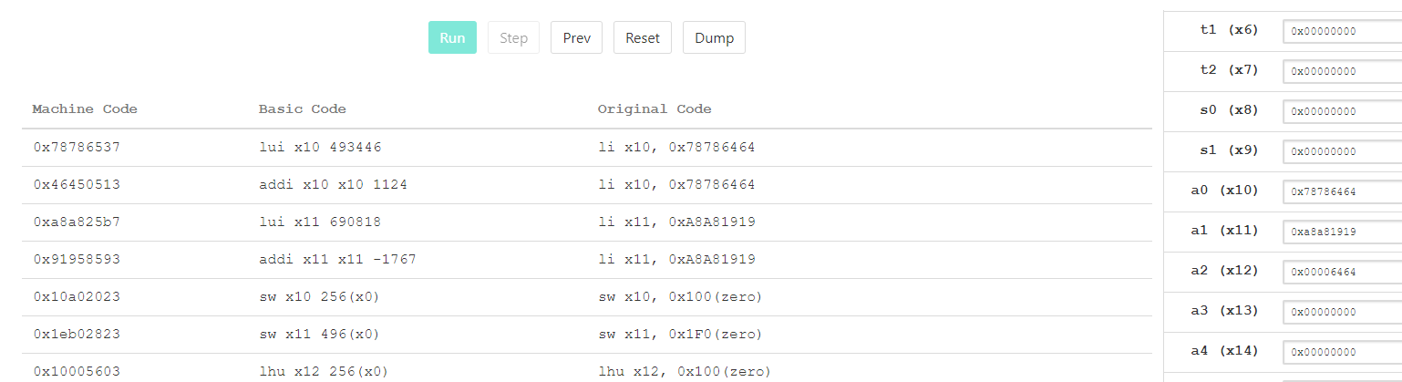

4) 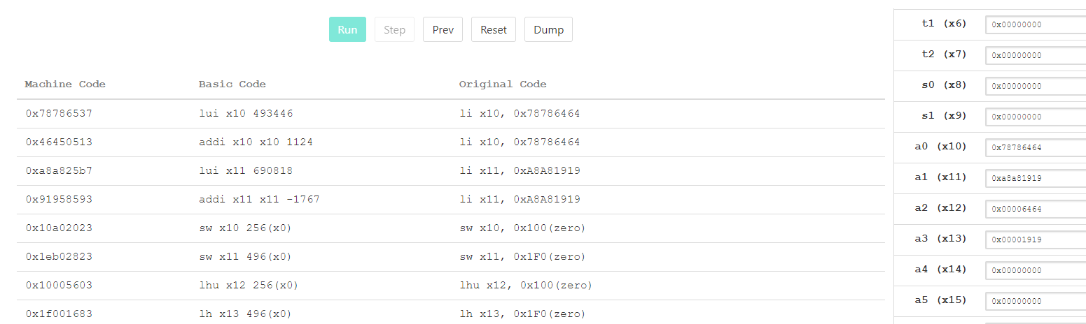

5) 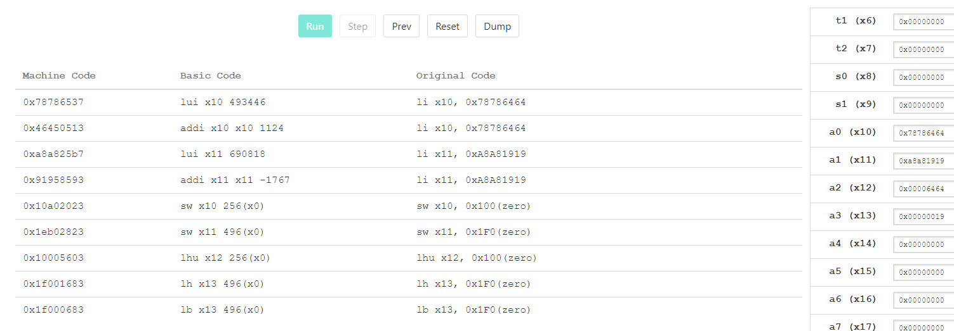

Task 2b,

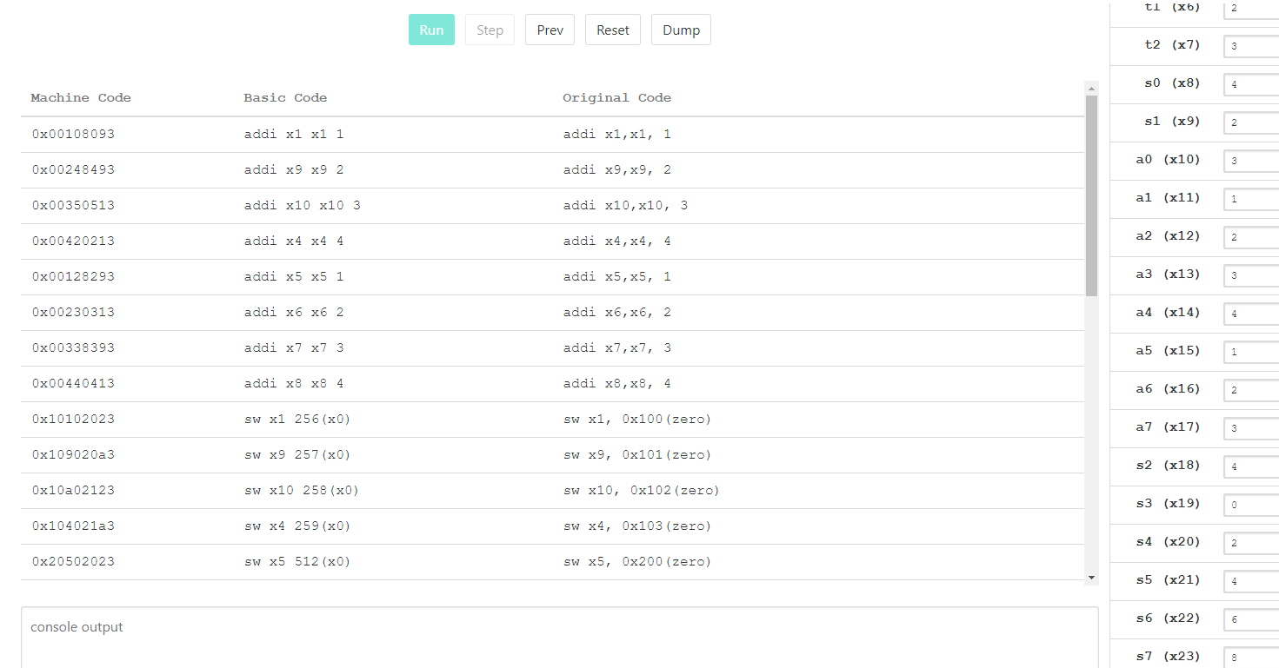



addi x1,x1, 1 # adding 1 and the value in x1 and storing it in x1

addi x9,x9, 2 # adding 2 and the value in x9 and storing it in x9

addi x10,x10, 3 # adding 3 and the value in x10 and storing it in x10

addi x4,x4, 4 # adding 4 and the value in x4 and storing it in x4

addi x5,x5, 1 # adding 1 and the value in x5 and storing it in x5

addi x6,x6, 2 # adding 2 and the value in x6 and storing it in x6

addi x7,x7, 3 # adding 3 and the value in x7 and storing it in x7

addi x8,x8, 4 # adding 4 and the value in x8 and storing it in x8

sw x1, 0x100(zero) # storing the value in x1 in memory 0x100

sw x9, 0x101(zero) # storing the value in x2 in memory 0x101

sw x10, 0x102(zero) # storing the value in x3 in memory 0x102

sw x4, 0x103(zero) # storing the value in x4 in memory 0x103

sw x5, 0x200(zero) # storing the value in x5 in memory 0x200

sw x6, 0x201(zero) # storing the value in x6 in memory 0x201

sw x7, 0x202(zero) # storing the value in x7 in memory 0x202

sw x8, 0x203(zero) # storing the value in x8 in memory 0x203

lbu x11, 0x100(zero) # loading the value in x11 in the memory 0x100

lbu x12, 0x101(zero) # loading the value in x12 in the memory 0x101

lbu x13, 0x102(zero) # loading the value in x13 in the memory 0x102

lbu x14, 0x103(zero) # loading the value in x14 in the memory 0x103

lbu x15, 0x200(zero) # loading the value in x15 in the memory 0x200

lbu x16, 0x201(zero) # loading the value in x16 in the memory 0x201

lbu x17, 0x202(zero) # loading the value in x17 in the memory 0x202

lbu x18, 0x203(zero) # loading the value in x18 in the memory 0x203

add x20, x11,x15 # adding the value in x15 and the value in x11 and storing it in x20

add x21, x12,x16 # adding the value in x16 and the value in x12 and storing it in x21

add x22, x13,x17 # adding the value in x17 and the value in x13 and storing it in x17

add x23, x14,x18 # adding the value in x18 and the value in x14 and storing it in x18

sw x20, 0x300(zero) # storing the value in x20 in memory 0x300

sw x21, 0x301(zero) # storing the value in x21 in memory 0x301

sw x22, 0x302(zero) # storing the value in x22 in memory 0x302

sw x23, 0x303(zero) # storing the value in x23 in memory 0x303

Explanation:

We are implementing iteration without the usage of for loop. We are repeating similar instructions, storing values in an array.